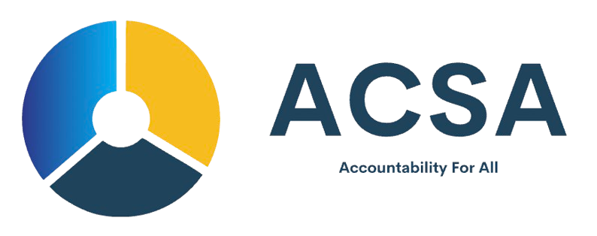

AFRICAN COMMISSION FOR STANDARDS AND ACCREDITATION (ACSA)

LETTER OF INTENT (LOI) FORM

Introduction
The African Commission for Standards and Accreditation (ACSA) encourages organizations, startups, NGOs, and emerging enterprises to submit a Letter of Intent (LOI) when expressing interest in accreditation, certification, or compliance programs. This LOI allows ACSA to understand your organization, its objectives, and your intended participation.

Section 1: Applicant / Organization Information
Organization Name: ________________________________
Registration / Incorporation Number (if applicable): ______
Country of Operation: ______________________________
Organization Type: (Corporate / NGO / Startup / Cooperative / Other) _______
Sector / Industry: ___________________________________
Address: __________________________________________
City / State: _______________________________________
Postal Code: _______________________________________
Website / Social Media Links: ________________________
Contact Person Name: ______________________________
Title / Position: ____________________________________
Email Address: _____________________________________
Phone Number: _____________________________________

Section 2: Purpose of Submission
Please describe the purpose of this Letter of Intent, including your interest in ACSA programs and expected outcomes:
_____________________________________________________
_____________________________________________________
_____________________________________________________

Section 3: Scope of Intent / Program Interest
Indicate the program(s) you intend to pursue (tick all that apply):
[ ] Corporate Certification
[ ] Corporate Accreditation
[ ] NGO Compliance Certification
[ ] AML/CFT Compliance Certification
[ ] Governance & Risk Management Certification
[ ] Sector-Specific Certification (Specify): _______________
Brief explanation of program interest / objectives:
_____________________________________________________
_____________________________________________________

Section 4: Organizational Overview
Provide a brief description of your organization, including vision, mission, key activities, and any relevant projects or achievements:
_____________________________________________________
_____________________________________________________
_____________________________________________________
_____________________________________________________

Section 5: Declaration & Signature
I hereby declare that the information provided in this Letter of Intent is true and complete to the best of my knowledge. I understand that submission of inaccurate information may affect consideration of our application.
Name of Authorized Signatory: ________________________
Title / Position: _____________________________________
Signature: _________________________________________
Date: _____________________________________________

Submission Instructions
Please submit this Letter of Intent via:
Email: applications@acsaafrica.org
OR via the secure ACSA Submission Portal

