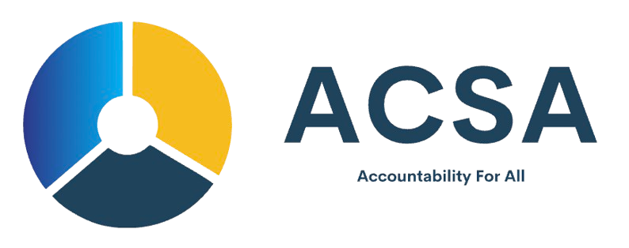

ACSA Application Form

Introduction
The African Commission for Standards and Accreditation (ACSA) is committed to promoting operational excellence, compliance, and governance across organizations in Africa. This application form is designed for all institutions, including startups, SMEs, cooperatives, NGOs, and emerging entrepreneurs seeking certification, accreditation, or compliance verification. Please complete this form as thoroughly as possible. Supporting documentation should be attached where applicable.

Section 1: Applicant Information
Full Name: _________________________________________
Title / Position: ____________________________________
Email Address: _____________________________________
Phone Number: _____________________________________
Organization Affiliation: ____________________________

Section 2: Organization Information
Organization Name: ________________________________
Registration / Incorporation Number (if applicable): ______
Date of Establishment / Founding: ___________________
Organization Type: (Corporate / NGO / Startup / Cooperative / Other) _______
Sector / Industry: ___________________________________
Country of Operation: ______________________________
Organization Address: ______________________________
City / State: _______________________________________
Postal Code: _______________________________________
Website / Social Media Links: ________________________
Number of Employees / Team Size: ___________________
Brief Description / Mission / Vision:
_____________________________________________________
_____________________________________________________
Key Organizational Goals:
_____________________________________________________
_____________________________________________________

Section 3: Leadership & Governance
Board of Directors / Executive Team (Names & Titles):
_____________________________________________________
_____________________________________________________
Governance Structure (Describe key roles and decision-making process):
_____________________________________________________
_____________________________________________________
Policies & Codes of Conduct in place:
_____________________________________________________
_____________________________________________________

Section 4: Operational & Compliance Framework
Operational policies currently in place:
_____________________________________________________
Compliance policies (legal, financial, ethical):
_____________________________________________________
Risk management frameworks (if any):
_____________________________________________________
Innovations / Technology / Processes:
_____________________________________________________

Section 5: Program Selection
Please select all programs you are applying for:
[ ] Corporate Certification
[ ] Corporate Accreditation
[ ] NGO Compliance Certification
[ ] AML/CFT Compliance Certification
[ ] Governance & Risk Management Certification
[ ] Sector-Specific Certification (Specify): _______________
Brief explanation of why you are applying / expected benefits:
_____________________________________________________
_____________________________________________________

Section 6: Required Documents Checklist
Please attach copies of:
[ ] Registration / Incorporation Certificate (if applicable)
[ ] Organizational Profile / Overview
[ ] Leadership / Governance Structure Documents
[ ] Operational Policies
[ ] Compliance Policies
[ ] Financial / Audit / Activity Records
[ ] Sector-specific Documents (for AML, NGO, governance programs)
Additional Documents for Startups / Entrepreneurs (optional):
[ ] Business Plan / Pitch Deck
[ ] Partnership Agreements / Collaborations
[ ] Innovation / Product Descriptions
[ ] References / Testimonials

Section 7: Projects, Achievements, and Challenges
Key Projects or Programs Undertaken:
_____________________________________________________
_____________________________________________________
Achievements or Milestones:
_____________________________________________________
_____________________________________________________
Challenges or Areas Seeking Support:
_____________________________________________________
_____________________________________________________

Section 8: Declarations & Signature
I declare that the information provided is true and complete to the best of my knowledge. I understand that providing false information may result in rejection or revocation of accreditation/certification.
Name of Authorized Signatory: ________________________
Title / Position: _____________________________________
Signature: _________________________________________
Date: _____________________________________________

Submission Instructions
Submit this completed form along with all attachments to:
Email: applications@acsaafrica.org
OR via the secure ACSA Submission Portal.

Office Use Only
Date Received: _____________________
Application Number: ________________
Review Officer: _____________________
Status: (Pending / Reviewed / Approved / Rejected) _______
Notes: ____________________________________________
____________________________________________

